**National University of Computer and Emerging Sciences, Karachi  
FAST School of Computing**

**CS3001-Computer Networks, Spring 2023**

**Group Members**

Fabiha Atique 20k-0369

Mohammad Usama 20k-0190

**Introduction:**

Rock Paper Scissors is a classic game that has been enjoyed by people of all ages for generations. In this project, we have implemented the game of Rock Paper Scissors using TCP sockets, allowing for multiple players to connect to a single server and compete against each other in real-time.

The project consists of three main components: the server code, and two client codes that represent the two players. The server code runs on a central machine and is responsible for coordinating the game and communicating with the clients. The clients, on the other hand, are the players themselves and are responsible for making their moves and receiving updates from the server.

To begin the game, both clients connect to the server using TCP sockets. Once connected, the server waits for both clients to send their moves (rock, paper, or scissors) and then compares them to determine the winner. The server then sends the results to both clients and the game continues until one player reaches a predetermined number of wins.

Overall, this project provides an interactive and engaging way to learn about TCP sockets and network programming, while all having fun with a classic game.

**Functional features:**

1. Game play
2. Score tracking

**Proposed Work:**

The project is about creating a rock paper scissors game over a TCP client server environment. There is one server and two clients, the two clients connect to the server and the game begins. There are three rounds played by the players and after this tournament the results are announced ( whether either of the players has won or there is a tie). The GUI has been implemented using the tkinter library.

**Methodology:**

1. Purpose: The game is designed for educational purposes to shoe hoe TCP client server connection can be used for different purposes.
2. Requirements gathering: The requirements we got were mostly the simple rules of the game and some were given by our instructor (that the game should contain multiple rounds and in the GUI there should be buttons for the options (rock, paper or scissors)
3. Design: By looking at the requirements, we designed the structure of our code, that there should be one server and two clients (as two players are there for this game).
4. Implementation: The implementation was done in python language on VS code, it took around one week for implementing this project. The server code is the main code which performs the actual game logic and allows the players to come and connect to the game. The clients join the network over TCP connection and play the game.
5. Testing: once the code was completed we both tested by running and giving different inputs and checking whether correct results are presented.

**Algorithms:**

1. Socket Programming

**Tools and technologies:**

* Language: Python 3
* Libraries: socket, threading and tkinter
* OS: windows

**Work Division:**

The project was done mostly on teamwork and discussion. The GUI was mostly done by Usama whereas the report was created by Fabiha.

**Code Snippet:**

**# Receive the players' moves**

**player1_move = player1_socket.recv(1024).decode()**

**player2_move = player2_socket.recv(1024).decode()**

**# checking winner**

**if player1_move == player2_move:**

**round_winner = 'Round ' + str(i+1) + ' is a tie!'**

**elif player1_move == 'Rock' and player2_move == 'Scissors':**

**round_winner = 'Player 1 wins round ' + str(i+1) + '!'**

**player1_score += 1**

**elif player1_move == 'Paper' and player2_move == 'Rock':**

**round_winner = 'Player 1 wins round ' + str(i+1) + '!'**

**player1_score += 1**

**elif player1_move == 'Scissors' and player2_move == 'Paper':**

**round_winner = 'Player 1 wins round ' + str(i+1) + '!'**

**player1_score += 1**

**else:**

**round_winner = 'Player 2 wins round ' + str(i+1) + '!'**

**player2_score += 1**

**player1_socket.sendall(round_winner.encode())**

**player2_socket.sendall(round_winner.encode())**

**Demo:**

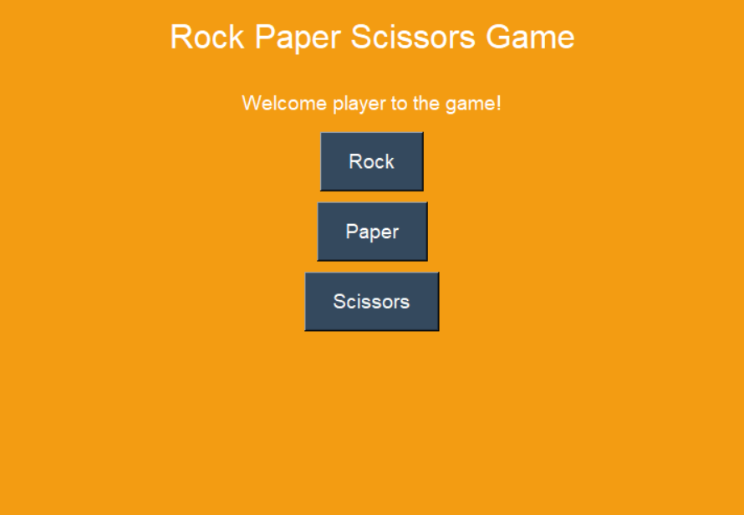

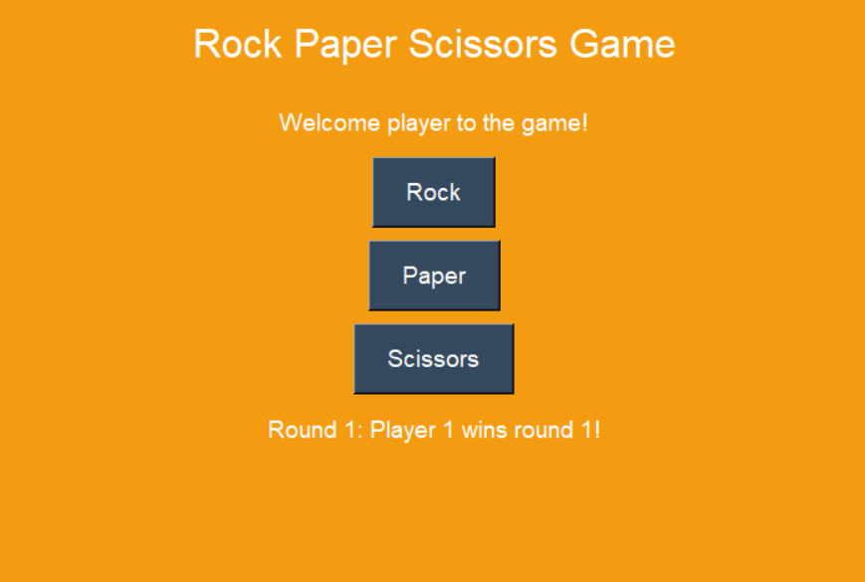

**References:**

* Python Socket Programming Tutorial: <https://realpython.com>
* Rock paper scissors game logic: https://realpython.com/python-rock-paper-scissors/
* TCPProtocol: <https://www.geeksforgeeks.org/tcp-server-client-implementation-in-python/>